ECA3101-NANO ELECTRONICS
Exp. 9. Simulation of Tunneling Magnetoresistance (TMR) by Varying Barrier Height using NanoHUB
TEST CASE-1: Characteristics of TMR with barrier height of 0.85eV
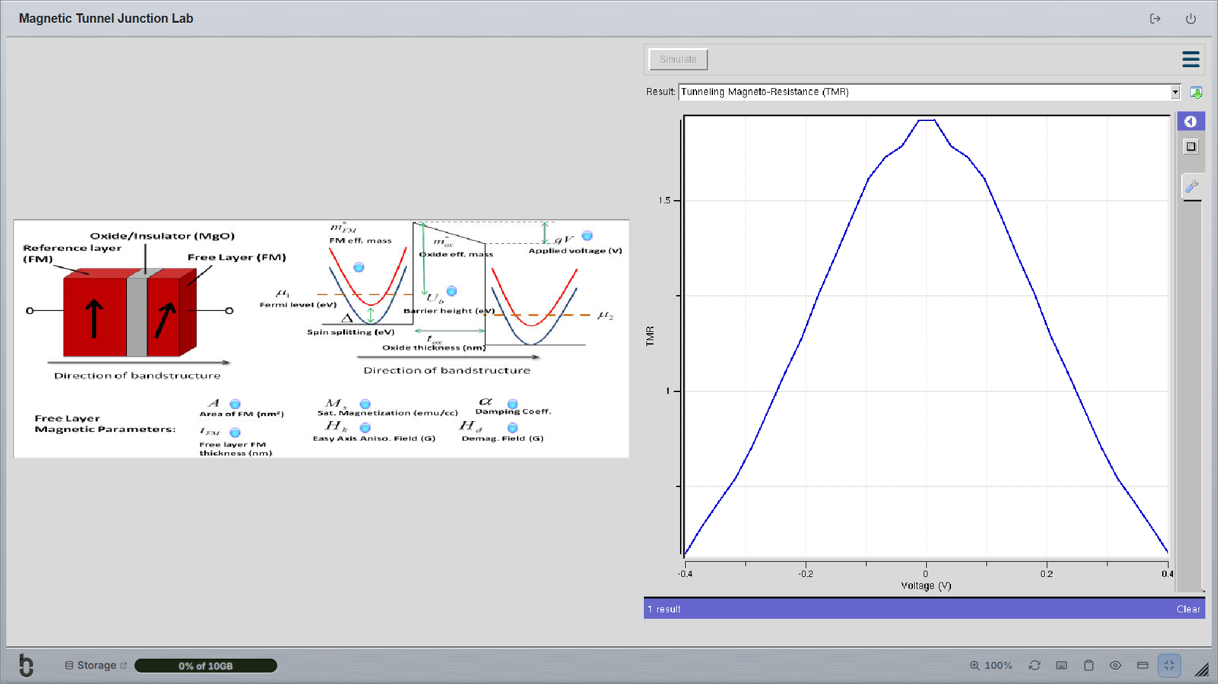
TEST CASE-2: Characteristics of TMR with barrier height of 1.0eV


